Name:Piyush Vishnoi

Sap:500067083

Roll no:71

Lab:7

Lab experiment - 7

Starting jenkins

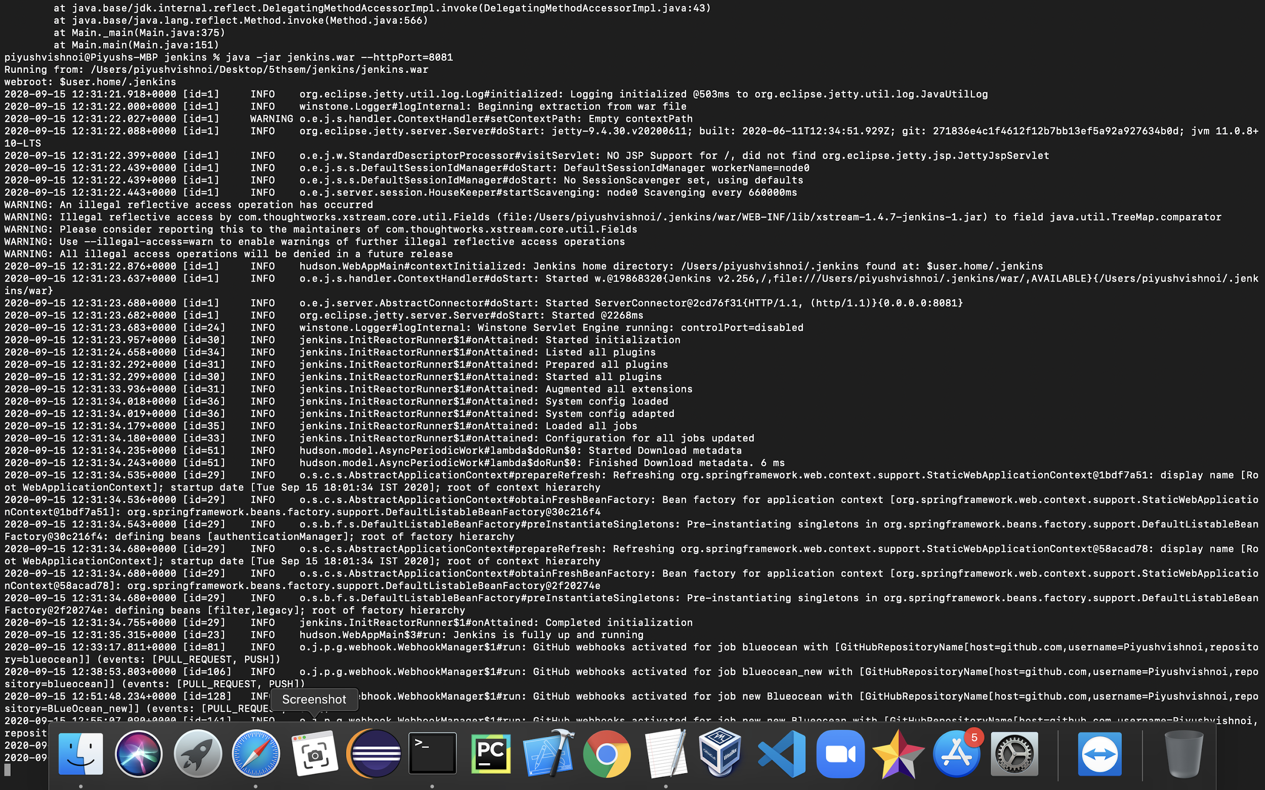

Successfully installed blueocean plugin

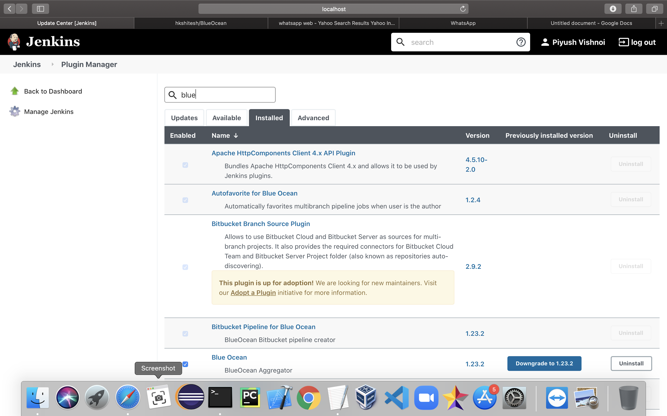

Successfully linked github account

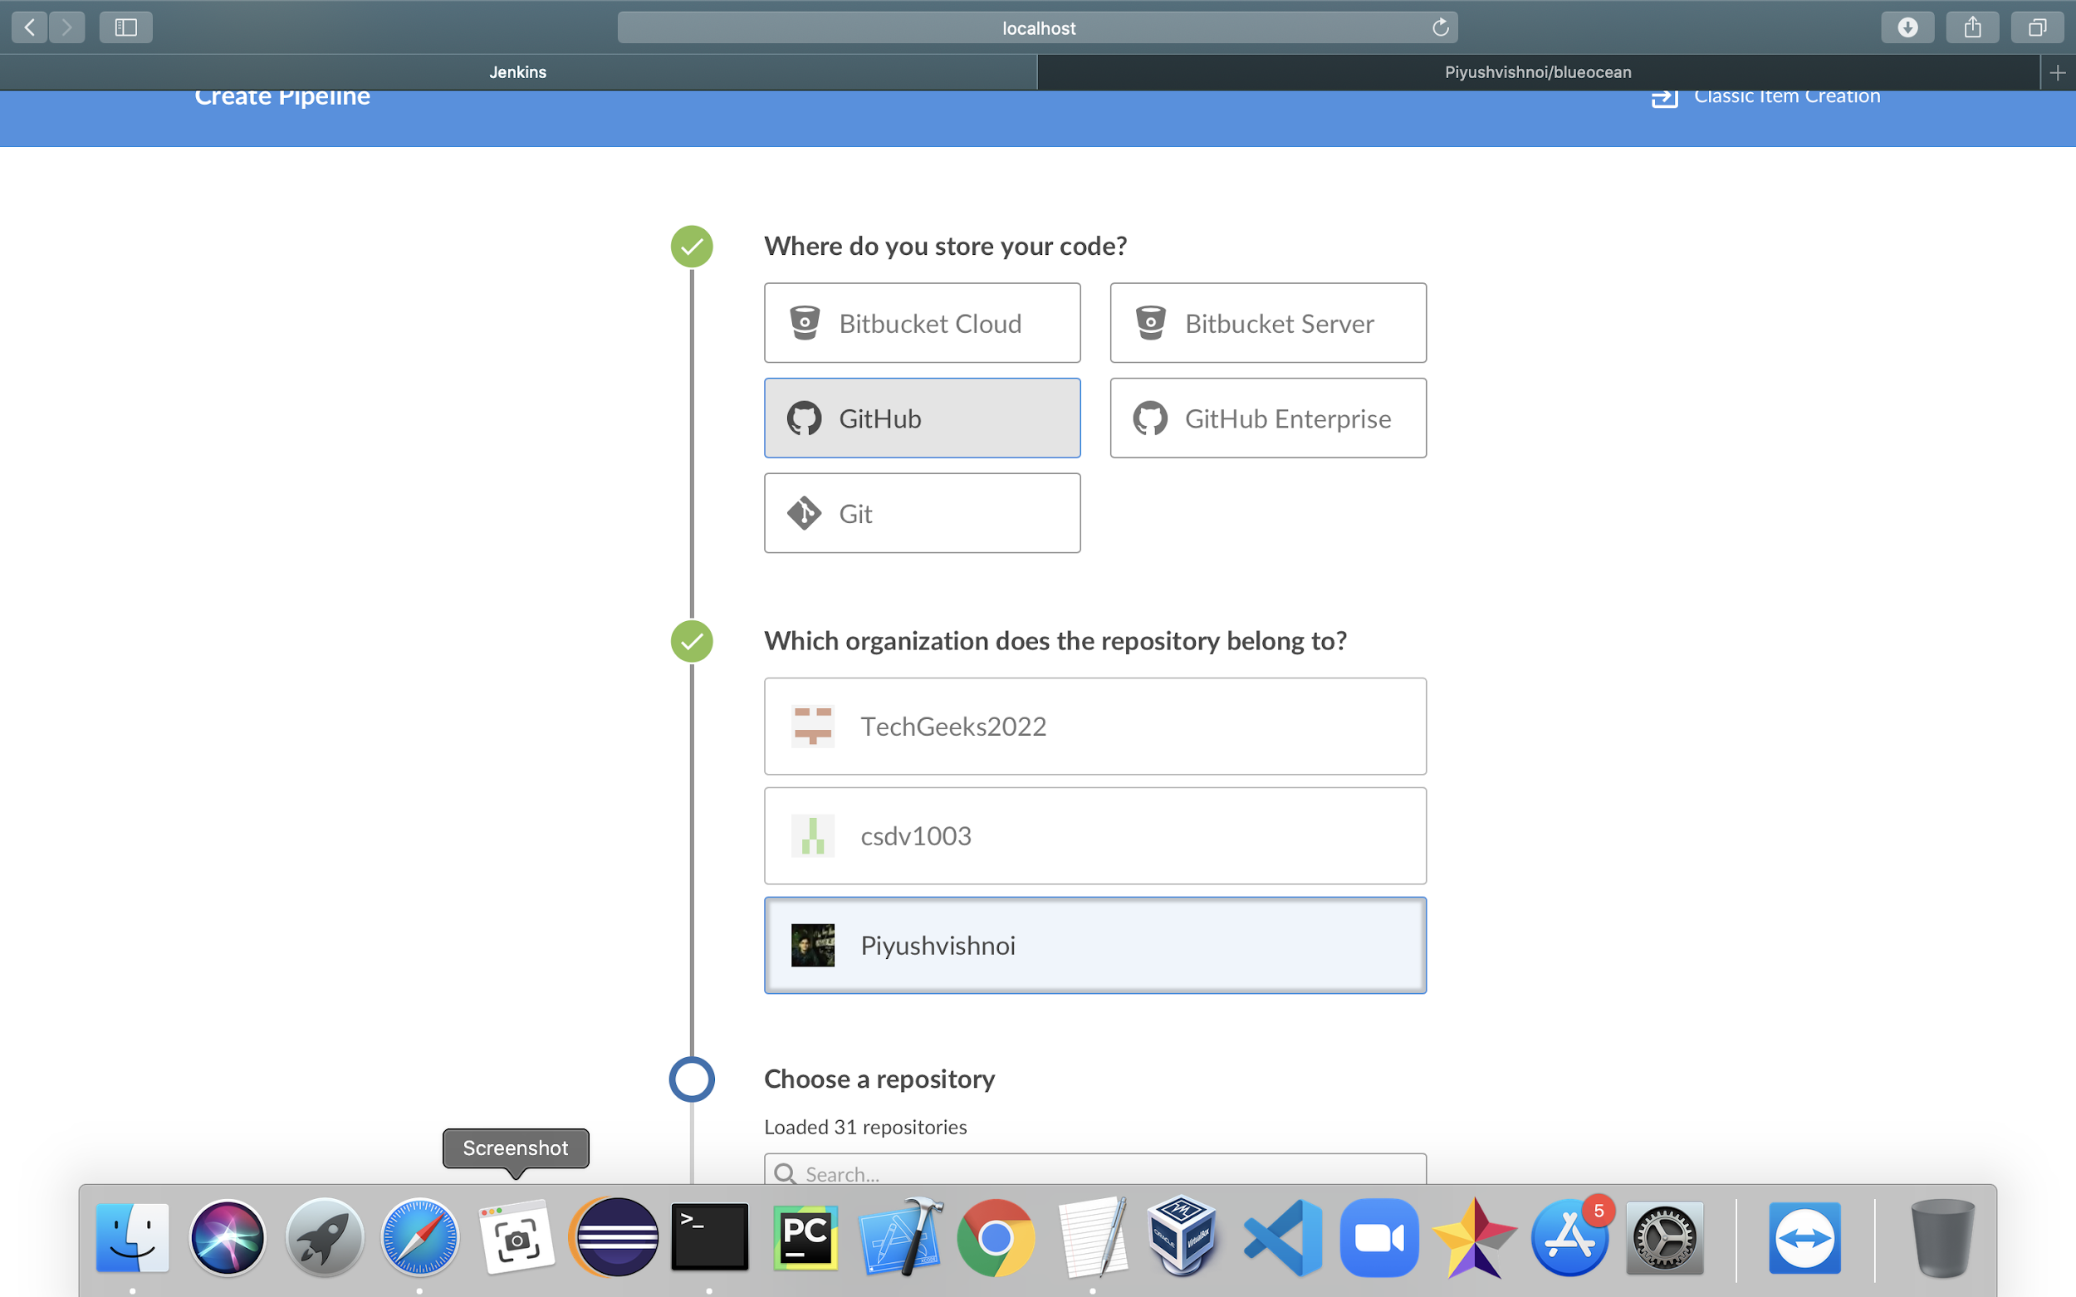

Created a repo with jenkins file

